Linear regression

Linear regression is a type of supervised machine-learning algorithm that learns from the labelled datasets and maps the data points with most optimized linear functions which can be used for prediction on new datasets. It assumes that there is a linear relationship between the input and output, meaning the output changes at a constant rate as the input changes. This relationship is represented by a straight line.

For example ;-we want to predict a student's exam score based on how many hours they studied. We observe that as students study more hours, their scores go up. In the example of predicting exam scores based on hours studied. Here
Independent variable (input): Hours studied because it's the factor we control or observe.
Dependent variable (output): Exam score because it depends on how many hours were studied.

Ip

Best Fit Line in Linear Regression
In linear regression, the best-fit line is the straight line that most accurately represents the relationship between the independent variable (input) and the dependent variable (output). It is the line that minimizes the difference between the actual data points and the predicted values from the model.

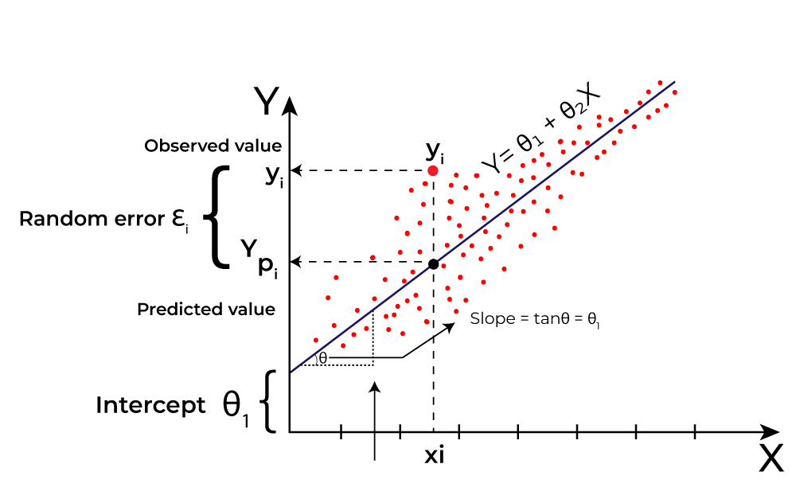
Here Y is called a dependent or target variable and X is called an independent variable also known as the predictor of Y. There are many types of functions or modules that can be used for regression. A linear function is the simplest type of function. Here, X may be a single feature or multiple features representing the problem.

Types of Linear Regression
When there is only one independent feature it is known as Simple Linear Regression or Univariate Linear Regression and when there are more than one feature it is known as Multiple Linear Regression or Multivariate Regression.
1. Simple Linear Regression
Simple linear reegression is used when we want to predict a target value (dependent variable) using only one input feature (independent variable). It assumes a straight-line relationship between the two.
Formula:
y^=θ0+θ1x
Where:
y^​ is the predicted value
xis the input (independent variable)
θ0 is the intercept (value of y when x=0)
θ1​ is the slope or coefficient (how much y^ changes with one unit of x)
Example:
Predicting a person’s salary (y) based on their years of experience (x).

2. Multiple Linear Regression
Multiple linear regression involves more than one independent variable and one dependent variable. The equation for multiple linear regression is:
y^=θ0+θ1x1+θ2x2+⋯+θnxnwhere:
y^​ is the predicted value
x1,x2,…,xnare the independent variables
θ1,θ2,…,θn are the coefficients (weights) corresponding to each predictor.
θ0 is the intercept

How it works:
Start with random values for slope and intercept.
Calculate the error between predicted and actual values.
Find how much each parameter contributes to the error (gradient).
Update the parameters in the direction that reduces the error.
Repeat until the error is as small as possible.
This helps the model find the best-fit line for the data.

Evaluation Metrics for Linear Regression
A variety of evaluation measures can be used to determine the strength of any linear regression model. These assessment metrics often give an indication of how well the model is producing the observed outputs.
The most common measurements are:

1. Mean Square Error (MSE)
Mean Squared Error (MSE) is an evaluation metric that calculates the average of the squared differences between the actual and predicted values for all the data points. The difference is squared to ensure that negative and positive differences don't cancel each other out.
MSE=n1​∑i=1n​(yi​−yi​​)2
Here,
nnis the number of data points.
yis the actual or observed value for theithithdata point.
yi​​ is the predicted value for the ithithdata point.

2.Mean Absolute Error (MAE)
Mean Absolute Error is an evaluation metric used to calculate the accuracy of a regression model. MAE measures the average absolute difference between the predicted values and actual values.
Mathematically MAE is expressed as:
MAE=1n∑i=1n∣Yi−Yi^
Here,
n is the number of observations
Yi represents the actual values.
Yi^​ represents the predicted values
Lower MAE value indicates better model performance. It is not sensitive to the outliers as we consider absolute differences.

